Computer Language Coding Concepts

Command References in a Command Call in a Diagram
Command references in a command call have been conceptually explained in the article Command References in a Command Call.

This article only illustrates how command references in a command call look in a diagram.

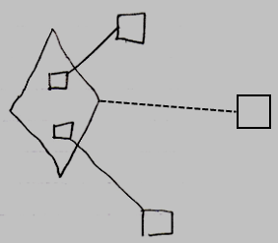

The diamond is a command call. The command call’s definition is indicated with the dashed line, pointing to the square on the right, which is the command definition. The smaller squares inside the call are command references in a command call. They are actually public command references. This makes the command references parameters of the command call. The command references have object lines, solid ones, going outside, ending at the targets of the command references.

The creation behavior of command references in a command call will not be further explained with diagrams in this article. Refer to the article Creation Behavior of Command Callls in a Diagram for an illustration of how the creation behavior of command calls looks in a diagram.

See also: Command References in a Command Call,
Creation Behavior of Command Calls in a Diagram

Author & Copyright: Jan-Joost van Zon Date: August 9, 2008 – August 9, 2008 Location: Oosterhout, The Netherlands Status: Finished

